**Visualisation 1:**

**Which is the most effective Real Estate Agency?**

Bar charts. (Managed by Qasse)

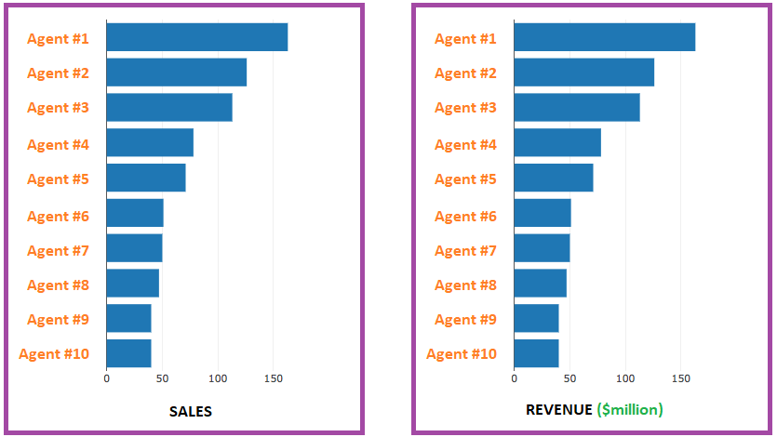

**Visualisation 2:**

**A study of the median house price in each Melbournian suburb.**

Heatmap with markers and tool-tips displaying each suburb’s median selling price.

Map to include an overlay of council divisions. (Managed by Joanna.)

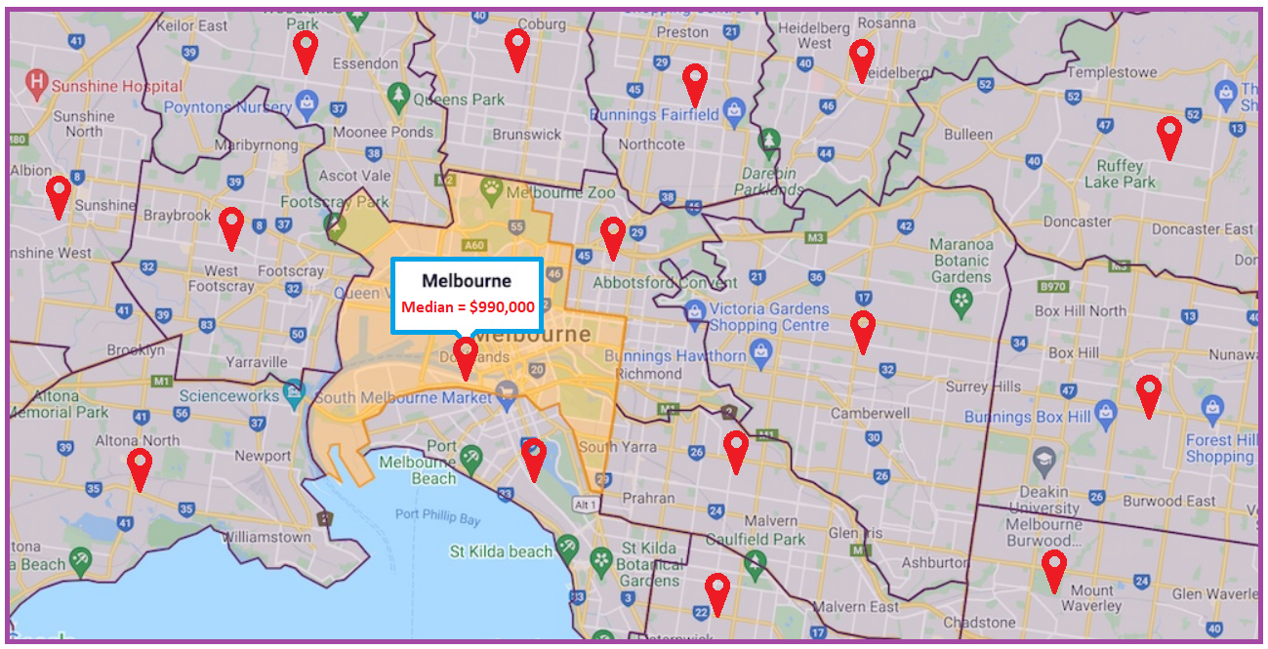

**Visualization 3:**

**A study of selling prices by ‘band’.**

Allocate all houses that sold a coloured marker based on selling price. (Managed by Christian)

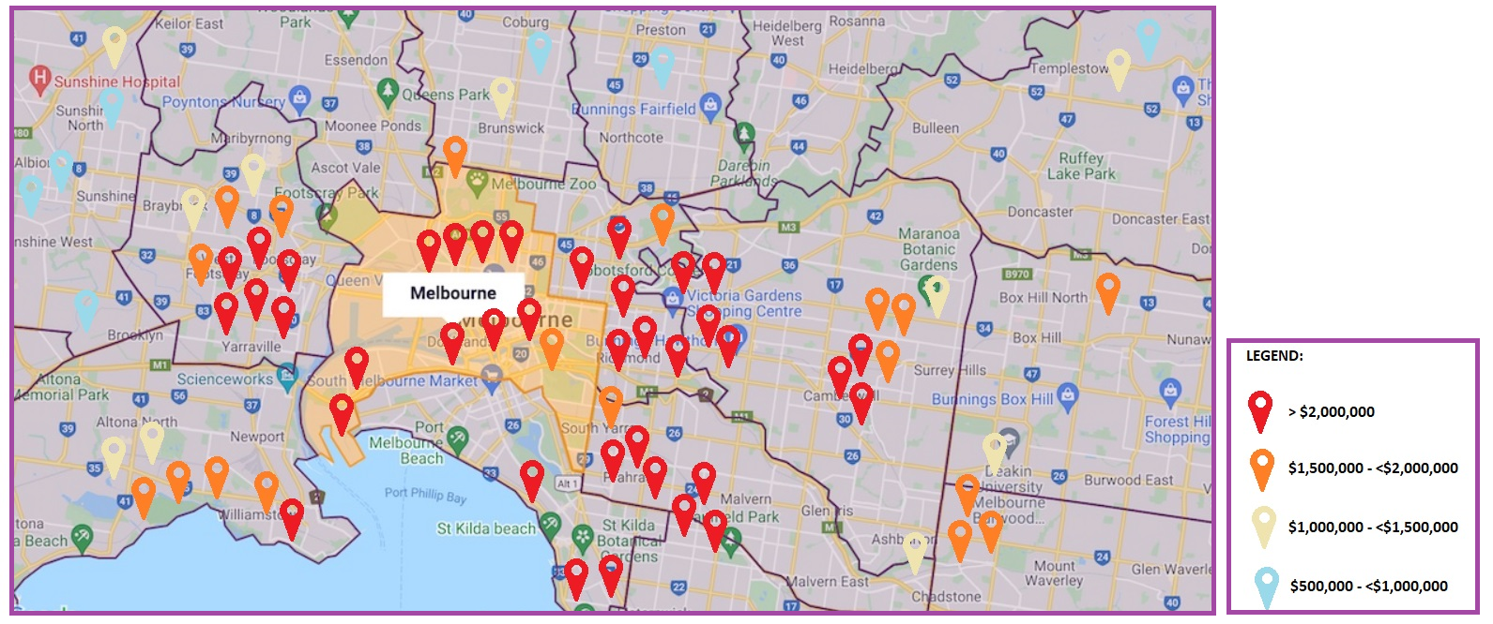

**Visualization 4:**

**A study of clearance rates by capital city.**

For each of Melbourne, Sydney, Brisbane, Canberra and Adelaide assign a white circle with a radius proportional to the number of properties that were on the market. Assign each city a smaller purple circle with a radius that is proportional to the number of properties that sold. (Managed by Chris and Navid)

